**EXPERIENCE AND GOALS**

As a teacher, I base my personal beliefs and teaching ideas on The Five Core Propositions for Teaching which serve as the foundation for all National Board standards and assessments, defining the level of knowledge, skills, abilities, and commitments that accomplished teachers demonstrate.

**Teachers are Committed to Students and Their Learning**

“All students can learn and succeed (but not on the same day in the same way). Success breeds success. Schools control the conditions of success.” As a teacher I was committed to finding out what students wanted out of homework and to inspire them to be consistent in completing their academic work each night. As we all know homework is one of the ideals to students’ academic success. This artifact met the proposition because my students were struggling completing homework and I was determined to find a way to encourage them to take homework seriously, and they eventually did.

**Teachers know the subjects they teach and how to teach those subjects to students**

It seems obvious that, if you are going to teach a subject, then you should really know a lot about the subject, right? There is a saying that, if you want to teach history, you should first learn a lot about history, and if you want to teach mathematics, then you should get a degree in mathematics. As a teacher, I demonstrated a wide range of different skills and attitudes to assist my students achieve high outcomes.

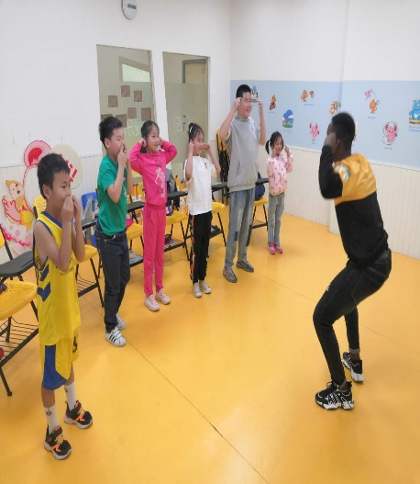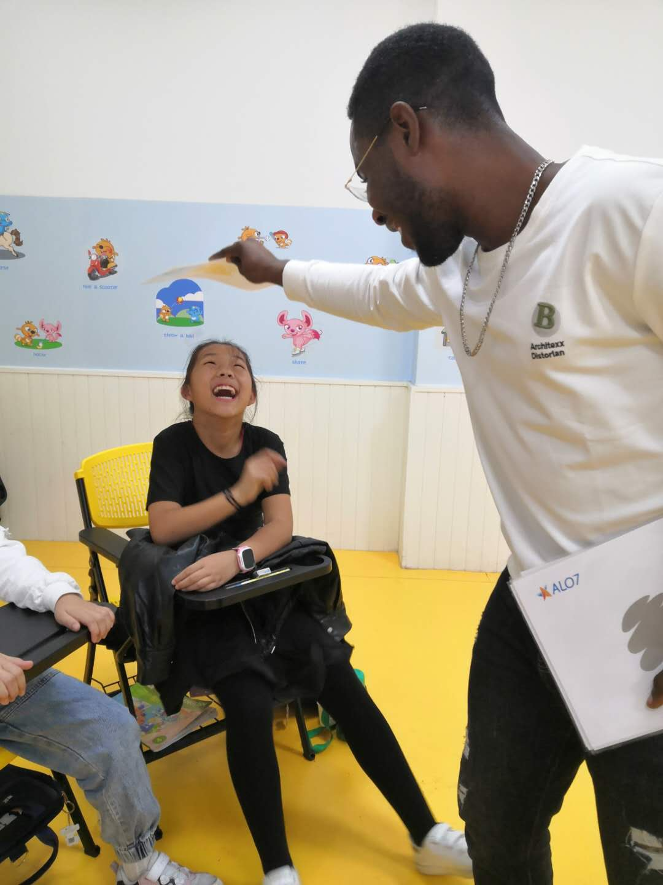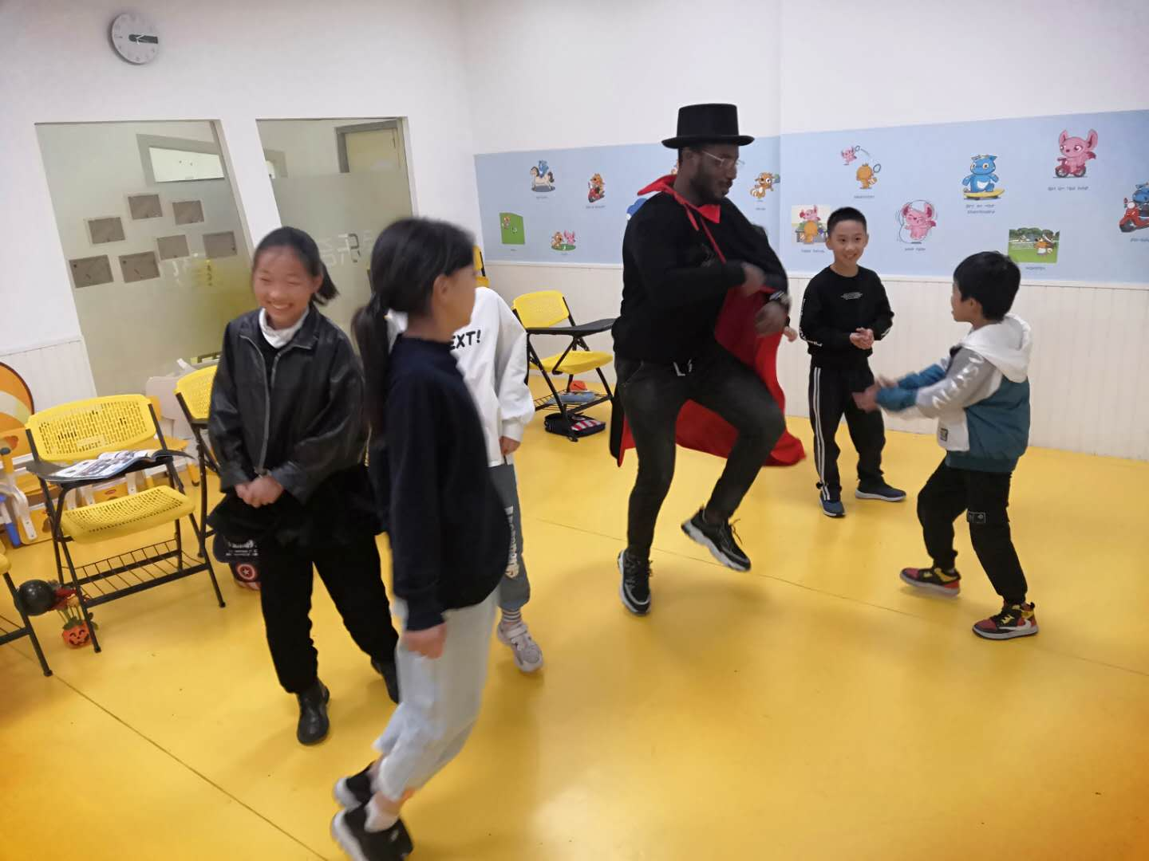

**Teachers are responsible for managing and monitoring student learning**

The role of teacher is changing in smart and active learning methodologies. Now teacher is as a facilitator in learning. Teaching and learning are being modified due to innovations in education. As a teacher, I take the role of a classroom guide rather than the traditional spoon feeding of students with knowledge. I give the learners the opportunity to be learners thus formulate their own thoughts to solve a problem. I create an activity-based learning environments for students to actively participate in the learning process.

**Teachers think systematically about their practice and learn from experience**

Reflective practice means learning through and from experience towards gaining new insights of self and practice, it’s also a systematic reviewing process for all teachers which allows you to make links from one experience to the next, making sure your students make maximum progress. I personally do think about my practice a lot, I recall a class where I was teaching on the topic “Some common sounds of animals” I selected few common animals, like the cat, dog, cow, duck, horse, cock. I had audios of animal sounds and pictures of some animals; I started the class with some warm up songs and some activities. After, I gave students the opportunity to mention names of some animal, later I made them produce the sounds of each animal they mention, after, we listened to the audios and identified the animals using the pictures on the flashcards. The problem I encountered was that I finished the content for the day before time and all the games and activities we were playing together were on the same set of animals so the students got bored and the participation was low. Realizing that, I gave students a 10 minutes break, sat and thought through about what next to do. I went online, downloaded videos of other animals, both common and weird ones, planned an animal story where student have to act as the animals and make their sounds. This strategy worked for me, I developed not just the instrumental skills of teaching, but the much deeper capacity to know what skills matter and when to use them.

**Teachers are members of learning communities**

Teachers have an enormous impact on our students and our learning communities. Shaping the minds of children is no easy task. Some educators take their devotion to teaching a step further by becoming teacher leaders. This teaching journey has been smooth based on the learning communities I found myself in, we collaborate, research, innovate, mentor and advise, among numerous other responsibilities. We evaluate school progress and the allocation of school resources in light of their understanding of state and local educational objectives and their knowledge of student needs.

**Shots of me and my students**

